George Liu

Possessive Perception in The Love Witch
The face is a delicate surface of sensation, with many sense organs configured on its receptive surface (eyes, nose, mouth, ears, skin), which also produces micromovements, as Gilles Deleuze points out in Cinema I: The Movement-Image (87–88). Deleuze posits that the face is constituted by the continuum of two poles. At one end, the face expresses interior forces of soul (micromovements) and at the other, exterior forces of matter (sensory surface). The dialectic of the inside and outside “actually unravels to reveal a notion of the ‘in-between’…which creates a middle place” (Teyssot 12). The face is one such interstitial surface that expresses the interaction between interior forces of soul and exterior forces of matter. Thus, the face becomes a potent intermediary surface by which we may begin to perceive the forces of soul and matter and their ensuing interactions, though sometimes indirectly and obscurely.
I wish to examine the site of the face using the mechanism of possession via perception outlined by Deleuze-Leibniz in The Fold. What a monad can unfold in its clear zone of perception is that which it possesses. To be seen or perceived distinctly, for instance by a lover, is to be enfolded: “What is folded is the included, the inherent. It can be stated that what is folded is only virtual and currently exists only in an envelope, in something that envelops it” (Deleuze, The Fold 22). The face is enveloped by perception, possessed by a lover. Degrees of clarity of one’s perception of another’s face and facial expressions are produced by manners of interfacing, which depend on the intensive and extensive state of those interfacing, as well as their spatio-temporal relation to one another. For instance, to directly interface means to orient oneself in relation to another’s line of vision such that both lines of vision coincide. Direct interfacing is one orientation that produces clear perceptions of faces.
The mechanism of possessive perception in The Fold aligns with the possessive love found within The Love Witch (2016). Before I dive into The Love Witch, I will sketch out the cosmology which Deleuze-Leibniz lays out in The Fold. I will align the possessive mechanism of monad’s perception with the model of memory and time laid out in Deleuze’s Cinema II: The Time-Image to understand how past perceptions sometimes haunt the present in a new, yet familiar form. Coupled with Alfred Gell’s art nexus, this will be the apparatus by which I understand the encounters between Elaine’s face and its recipients. Then, I will examine the manners of interfacing in The Love Witch, which situate the face as the index by which lover and beloved possess one another by filling one’s respective clear zone of perception with the visage of the other. I will use Alfred Gell’s understanding of the sticky social relations produced by some apotropaic patterns to inform my understanding the magnetic quality of Elaine’s face. The extent to which a lover may access their beloved’s soul in this relation of possession, however, remains to be seen.

Possessive Perception in The Fold
To build a working understanding of the how perception may operate possessively, I look The Fold, in which Deleuze coopts the convolutedly elegant closed cosmology posited by Leibniz and opens up this world predetermined by God into a world that diverges from itself through a reading of Whitehead’s process philosophy. As the building block of this universe, Deleuze-Leibniz offers the monad, a simple substance whose existence is defined by its perception of the entire world from its singular point of view. The world is consequently constituted by the series of infinitesimal differences in point of view. The infinite series (the world/God) does not exist outside of the perceptions of the finite terms (the monad) which constitute it. Because the world is infinite and the monad finite, the monad only perceives and expresses a small portion of the world clearly and distinctly: “It might even be stated that insofar as it is filled with folds that stretch to infinity, the soul can always unfold a limited number of them inside itself, those that make up its subdivision or its borough” (25). Perceptions which can be unfolded by the soul constitute the clear zone of a monad. What is actual for the monad is what is unfolded in its clear zone of perception, while the virtual remains enfolded and obscure, beyond the limits of its clear zone.
But what determines a monad’s clear zone of perception? Deleuze-Leibniz says that it is the monad’s body, which exists on the lower floor of the monad (the upper floor being the sealed off folds of soul). The folds of matter are filled with material receptors (sensory organs) which sense the vibrations of all the other bodies within the physical universe (however dimly or obscurely). These tiny and obscure folds are microperceptions, which connect the monad via perception to the rest of the world which it perceives entirely, however dimly. Microperceptions are filtered by differential relations within the monad’s clear zone of perception into macroperceptions in a movement from the “ordinary” to the “remarkable” (88). The monad perceives what is remarkable to it from its point of view, what is remarkable determined by what it cares about and what territories of its world its clear zone occupies. What happens to the monad’s body is what it represents clearly or obscurely in its soul. To perceive is to feel one’s own body affected by other bodies via the folds of matter.
Our awareness of the existence of the monad’s body, however, cannot be take for granted. Perception, and the singular point of view which produces it, is the ground of existence for the monad, rather than an external material world: the world and its objects come into being (actualize) through the point of view of the monad (89). The world is not given as an external object but must be unfolded in the clear zone of the monad in order to be perceived and grasped consciously, and thus actualized. Perception in the monad is thusly hallucinatory (93). Because obscure microperceptions and clear macroperceptions in the monad are the grounds from which the world springs, so too does the monad’s body spring from this hallucinatory ground. Rather than assume the existence of bodies as a given, Deleuze-Leibniz asserts that the monad’s body is produced through a relation of resemblance between the folds of soul and the folds of matter: “A quality perceived by consciousness resembles the vibrations contracted through the organism (97). Deleuze gives the example of how bodily pain of a needle entering flesh represents itself in the soul: the pain a monad perceives in its soul does not resemble the movement of the needle itself (a linear motion), but rather the motion of pain through the body (vibratory and pulsating) (95). It is this strange reciprocal relation of resemblance that produces the body and its representation within the soul. Neither soul nor body can exist independently or prior to the other: having a body is necessary for having a clear zone of perception, just as the body is realized through the monad’s clear zone of perception. When I examine The Love Witch, this relation of resemblance helps me to understand how respective clear zones of perception determine and express the efficacy of Elaine’s love magic.
Deleuze-Leibniz’s cosmology operates through the mechanism of inclusion—through perception, the world is included in the monad’s soul and expressed by its body. Simon O’Sullivan points out the possessive nature of perception in the monad in his essay, “From Possible Worlds to Future Folds (Following Deleuze): Richter’s Abstracts, Situationist Cities, and the Baroque in Art,” that what is included in “my” clear zone is “my” world: “It is in this sense that Deleuze reads Leibniz as setting forth an ontology of having over being. Life becomes a question of ownership, and of its crisis … for parts are constantly leaving, more often than not captured by other monads” (O’ Sullivan 312). The monad possesses what it perceives clearly, that which it can unfold from its singular point of view. I propose that this dynamic of possession of one’s own being could potentially mapped onto the possession of another being, as seen in the obsessive and possessive love affairs that take place in The Love Witch. The lover’s perception becomes filled with the image of the beloved (especially their faces), such that they cannot perceive anything else. Especially remarkable past perceptions of a beloved also refuse to fold and remain present in the lover’s clear zone. However, the faces that haunt the lovers through their beloved’s absent presence must be differentiated from the actual face of the beloved: the evocation of memory produces an entirely new object from the past perception: the “recollection-image.” I borrow this term from Deleuze’s chapter “Peaks of present and sheets of past” in Cinema II: The Time-Image in which Deleuze draws on the philosophy of Henri Bergson to analyze cinematic treatments of time and memory. Past perceptions are folded within the soul of the monad, forming virtual sheets or regions of the past. In order to unfold a present which has passed (an attempt to evoke memory), the monad plunges into virtual sheets of past from its fixed point in the present in an attempt to recover a recollection-image, which is an actualized artifact from the virtual past, a new object produced by the exploration of the sheets of past. Sometimes, the recollections-images take on a life of their own as “hallucinatory presences,” by which the past haunts the present (Deleuze, Cinema II 114). Within The Love Witch, the beloved’s face, once perceived clearly and possessed by the lover, refuses to fold into obscurity, filling the lover’s clear zone of perception and screaming for extension, haunting the lover sometimes even to death.
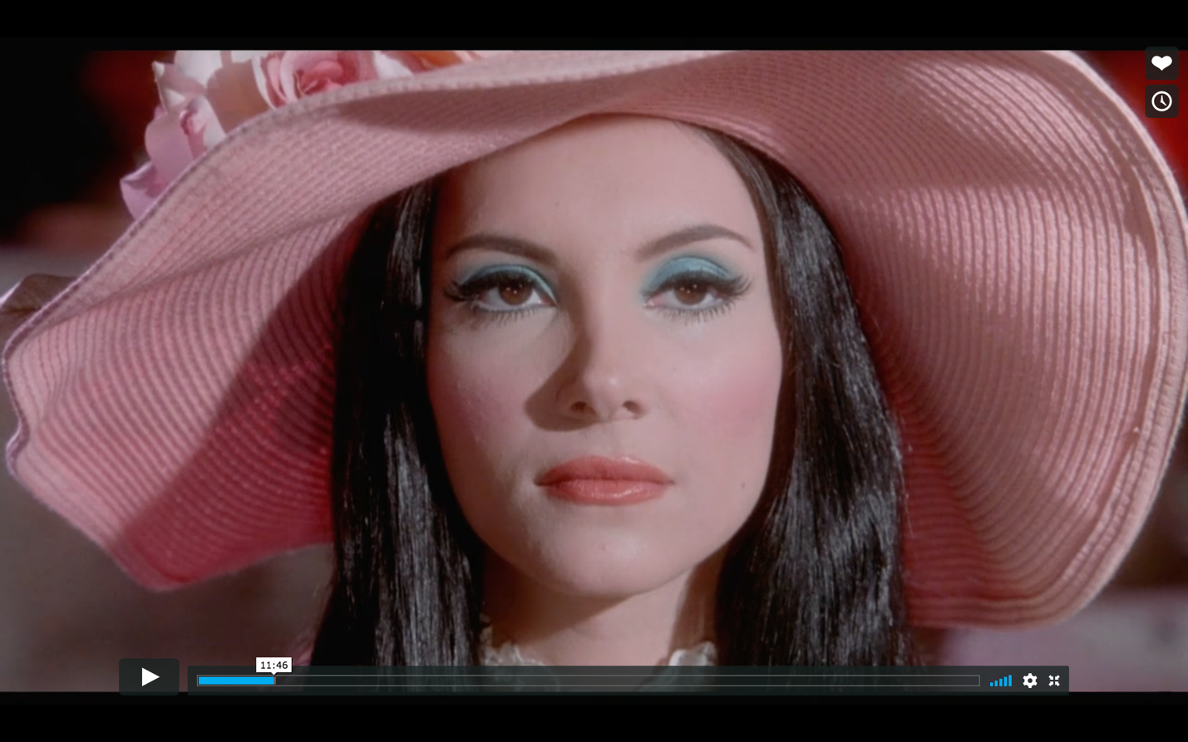
Elaine’s Face
I turn now to The Love Witch (2016) directed by Anna Biller, a highly seductive and fetishistic film about a witch named Elaine Parks, played by Samantha Robinson, who is obsessed with “perfect love,” a heteronormative ideal of love often embodied in Western fairy tales. It is a type of love that reigns eternally, in which lover and beloved may live happily ever after. Anna Biller’s obsessive style reflects the film’s obsessive subject matter: intensely mannerist, every second and inch of the film is densely packed with Biller’s clear aesthetic decisions. The Love Witch’s cinematography draws out distinct, and glamorized perceptions of its faces through direct interfacing (as we and Elaine’s lovers are often locked in Elaine’s direct and domineering glare) and the hypervisuality of The Love Witch (camerawork and stagecraft which expressly indulges in the pleasures of surface and texture, especially that of the face). Elaine’s face remains a beautiful yet impenetrable mask throughout the film, like a one-mirror allowing her to perceive the world clearly while her own soul remains relatively imperceptible and inaccessible.
Elaine’s single-minded pursuit of “perfect love” is reflected by the construction of her face via her stylized appearance and Samantha Robinson’s performance. Elaine’s face becomes a mask which haunts her lovers through the artifice of her hair and makeup (that refer to trends of 1960s Hollywood glamour which prioritizes the production of superhuman allure, beauty, and mystery) and Samantha Robinson’s aloof demeanor. The physical construction of Elaine’s face remains consistent throughout the film, save variations in color. We never see Elaine without her immaculate mask, constituted by a shimmery pastel eyeshadow in a cool tone, a warm glossy lip, sharp cat eyeliner, lash extensions, rosy blush, and a second wig which adds height to her hair. Her face, painted with makeup, remains unfolded in our clear zone of perception throughout the movie—even when she is sleeping, Elaine does not remove her makeup. Her mask is a prosthetic that actually becomes her face through its stubborn continuous embodiment in the film. The impenetrable quality of Elaine’s mask is furthered by Samantha Robinson’s mannerisms in her performance as Elaine: Robinson maintains opaque configurations of her facial expressions. During interactions with other characters, Robinson performs bored, detached, sometimes even disdainful expressions, her eyes seductively half closed, lips slightly pouted, any micromovements of her facial features kept to an expressive minimum (save for when she loses control of a situation and shrinks to a state of terrified infantilism). Even when she eats, Robinson takes tiny and rapid bites, as if to minimize any potential perceptions of imperfections in her beautiful mask. Recall Deleuze’s conception of faciality, which consists of the two poles of a sensory surface that gathers micromovements and consequently expresses exterior and interior forces on its surface. Elaine’s face stubbornly refuses to express any variation in interior and exterior forces on her body/soul in the present (disaffection), but rather expresses an unvarying power which she has decided upon, namely her obsessive desire for a transcendental ideal of “perfect love.” In Elaine’s continuous decision to withhold the expression of interior and exterior variation, her face becomes a one-way mirror through which she perceives the world, but the world may not perceive her soul.
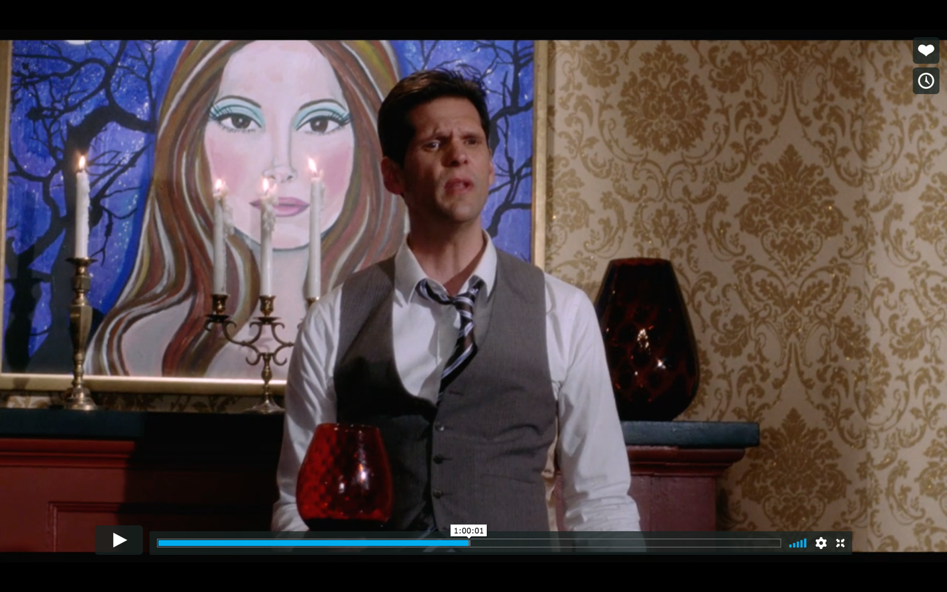
Elaine’s Face as Index
Here, I find Alfred Gell’s theory of the art nexus and his analysis of apotropaic patterns, specifically kolam (as they are known in Tamil Nadu, South India, and produced daily at the thresholds of houses by women in order to prevent the entrance of harmful demons), helpful in understanding the magnetic relation produced by an art object which refuses to be perceived completely. Before his examination of the social operation of these patterns, Gell fleshes out his anthropological model of the art nexus, which describe relations between artists, indexes, recipients, and prototypes. Artists are embodied entities which exert social agency on the index; indexes are embodied entities which are materially caused by an artist; recipients are embodied entities which encounter and perceive the index; and prototypes are the models by which the artist realizes the index, algorithmic in the case of apotropaic patterns. However, a hylomorphic understanding of the process of becoming embodied, which considers matter as passive and form as active, limits the capacity for matter to act, in the sense of acting in relation with another embodied entity. In “The Genesis of The Individual,” Simondon argues that to understand the individual which has come into being, one must look not to the individual (understood as a product) but rather to the process which individuates the entity (Simondon 300). And this process is entirely relational, existing between encounters between entities which are perceived by each other in varying degrees of clarity/obscurity. I find resonance between Gell’s relations between embodied entities and Deleuze’s relations of the monads. Deleuze expands an anthropocentric understanding of souls into one which encompasses all matter: “Universality does not exist, but living things are ubiquitous” (Deleuze, The Fold 9). While the world consists of infinite variation, souls are omnipresent. The ensouled matter that constitutes the body of the index may be in accordance or discordance with the artist’s own soul and the many souls which comprise the body of the artist, to evoke Deleuze’s discussion of the songs of converging and diverging monads in the final chapter of The Fold. While the souls of monads may not communicate directly, bodies of the monads may, through their respective clear zones of perception. Within the art nexus, the prototype is the model actualized in the soul of the artist monad, before realized or embodied as the index in matter. The recipient perceives the index in its clear zone of perception as determined by its body, and in doing so, may begin to “read” the perceptions in its soul, to unfold the information embedded within the index. In Gell’s art nexus, social agency only exists relationally, produced during an encounter between these terms. Gell also emphasizes the mobility of these reciprocal relations.
After fleshing out his model of the art nexus, Gell argues that the intricate patterning of these drawn designs neutralizes harmful demons by attracting their attention but remaining beyond understanding: “Kolam are sinuous, symmetrical figures which are usually very difficult to ‘read’ in the sense that it is difficult to see how the design has been constructed” (Gell 85). This cognitive blockage in perceiving the prototype produces a relation of social attachment in the encounter between the index and its recipient. Gell describes the experience of grappling with the complex algorithmic patterns of a carpet: “Who, possessed of an intricate oriental carpet, can say that they have entirely come to grips with its pattern; yet how often the eye rests on it and singles out now this relation, this symmetry, now that. The process can continue interminably; the pattern is inexhaustible, the relation between carpet and owner, for life” (80). The information embodied within the index (in this case a carpet) is never fully possessed by the recipient, but rather produces a relation of perpetually becoming possessed. In these cases, the act of possession through perception continues indefinitely.
While the glamour found within The Love Witch does not produce social attachment through intricate patterning, glamour often operates in a manner similar to the cognitive stickiness of intricate apotropaic patterns, as Laura Marks suggested during her seminar A Deep History of the Arts of the Secret. Glamour is often associated with beauty (of course a subjective and fickle quality, but a quality nonetheless) and shimmering, sparkling light (of jewels or makeup which adorn the figure). This is only one conception of glamour but one that is present in the manners of interfacing between Elaine and her lovers. When one perceives a beautiful entity, as in the instance of Elaine’s face, one’s curiosity or desire may be provoked. One might feel the urge to perceive clearly and thus possess the mysterious and beautiful entity. However, the alluring figure uses jewels to bedazzle the onlooker or reveals little of their soul through limiting facial expression. It is through both physical and spiritual blockage which produces a magnetic quality in a glamourous person, prompting a simultaneous attraction and repulsion. One’s desire to perceive clearly, and thus unfold, the body and soul of a glamourous figure is blocked not only by their sparkling surface, but often also an impenetrable persona. Guarded giving produces magnetism, revealing enough to whet an onlooker’s appetite, yet not enough to satisfy it. Thus, the source of Elaine’s face’s magnetic power is her ambivalent expression coupled with her beautiful appearance (beautiful in a very limited sense, but nonetheless intensely so). While her beauty attracts perception, her limited facial micromovements block any potential interpretation from without of her interior folds of soul. Like the apotropaic patterns, Elaine’s face enters into relations of becoming possessed with no promise of completion.
Before she possesses or is possessed by a lover, Elaine possesses herself. Outside of encounters with lovers, Elaine’s fills her clear zone of perception with her own face: she is both the artist and the recipient in relation to the index of her face. The index of her face resembles the prototype of her ideal of “perfect love.” Elaine refuses to express the constant variations of her internal state, but rather chooses to express a predetermined, eternalized ideal. Her clear zone of perception is filled with her pursuit of “perfect love” and an idealized model of herself, an object perfectly crafted to be perceived, and thus and possessed. In fact, during Elaine’s romantic conquests, it is not her actual self that is possessed, but rather a projected ideal of herself. Elaine extreme self-possession/perception approaches perfection in her acute awareness of how she wishes to be perceived and refusal to break from the transcendental model of beauty which she has constructed for herself. Elaine’s projected ideal (prototype) is especially evident in the paintings that adorn her apartment walls. Artistic production figures centrally within Elaine’s magic practice and her apartment overflows with self-portraits often depicting scenes of romantic conquest, references to astrology and tarot, and sometimes simply her hypnotic gaze. We even see shots of her in the act of painting, with closeups of the touch of the brush on the surface of the painting, though there is often no paint on the brush resulting in a strange empty gesture. Elaine’s female protagonists gaze directly out from the paintings with faces resembling Elaine’s makeup and disaffected expressions. Elaine obsessively embodies the prototype of her “perfect” face in her paintings (also indexes), as if to practice for the canvas of her own skin. Her paintings clarify her own remarkable perceptions of her prototype, thus intensifying the efficacy of her index (face) during actual encounters. Elaine’s apartment becomes a mirror chamber that fills her clear zone of perception with her own face and desires, compounding the potency of her love magic.
Elaine’s face (index) is received by her lovers during moments of direct interfacing, in which her intense gaze focuses her distilled desire to possess “perfect love” via clear perception. These intense moments of possession are perceived from the point of view of her lovers, often aligned with that of the audience. Biller focuses the power of Elaine’s face simply through close shots which fill the frame with Elaine’s face. In these close shots of Elaine’s face, we enter as recipients into a relationship of direct interfacing with her index, and our clear zone of perception (the frame of the film) is filled with her face. The scale of the close shots clarifies the microperceptions of the face’s textures which only become clear within intimate proximities. Up close, we can see the shimmering pigment of her eye shadow, the gloss of her lips, the burning glint in her eyes—the miniscule perceptions of reflected light that express the textures of her face. The intensity of Elaine’s desire seems localized in her eyes, as expressed by even closer shots of just her eyes. However, the microperceptions are not so clear/autonomous that they escape the dominant unity of her face. Elaine’s dark hair frames her pale face, focusing our perception of its unity, while the hazy filters Biller puts over these shots smooths some of the face’s textures, while still allowing the close-up to render the materiality of Elaine’s face clearer than from afar. Our perception of Elaine’s face in these shots is mediated by the glamorous sheen of Biller’s cinematographic style. However, rather than dull the potency of Elaine’s face, this mediation amplifies its hypnotic aura. Our distinct perception of Elaine’s face, determined by the point of view of the camera, allows us and her lovers to possess the projected ideal of beauty she has crafted. We can see this clearly in Elaine’s encounter with Wayne, the first lover she possesses in the film.
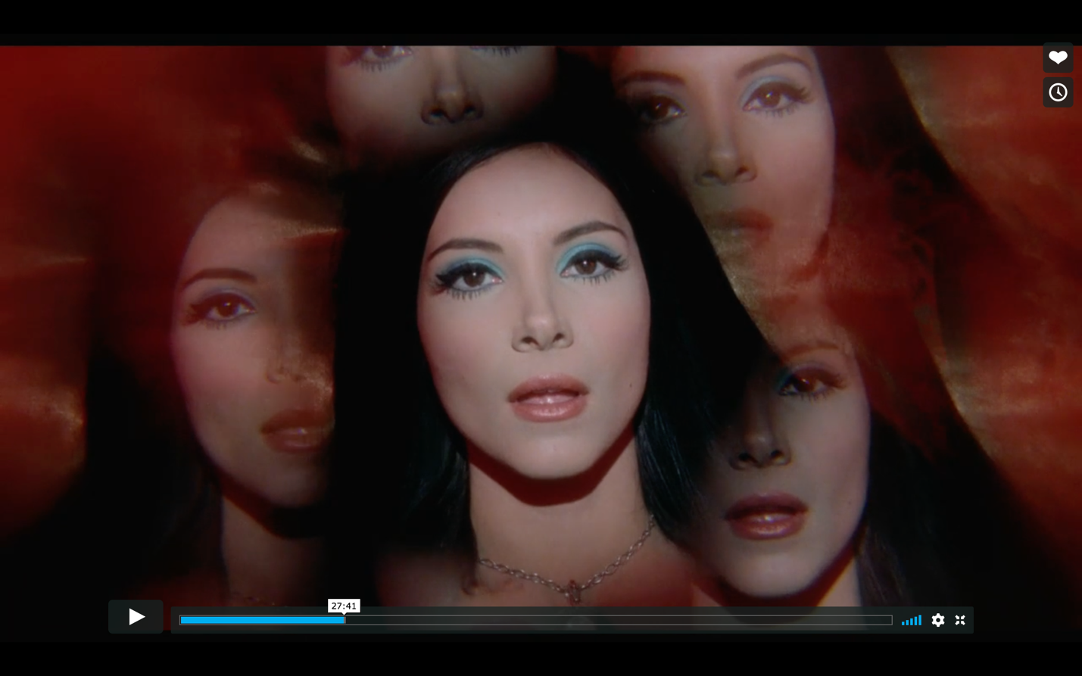
Elaine and Wayne, Direct Interfacing
The encounter with Wayne begins with Elaine eating a sandwich on a park bench. She spots Wayne across the park, and she begins to stare intently in his direction. From the shot of Wayne talking to his girlfriend Shelly across the park (which aligns with Elaine’s line of vision), Biller cuts quickly to a compositionally identical shot of Elaine’s ex-lover, Jerry, also in the act of talking. Biller uses this intercutting technique throughout the film to evoke intrusive thoughts—recollection-images which surface from the past as if of their own volition. In this instance, Jerry’s past presence (embodied by the recollection-image of his face) maps itself onto Wayne. Here, the absent presence of a past lover, indexed by his face, reembodies itself (albeit representationally within Elaine’s mind/soul), filling Elaine’s clear zone of perception briefly and intensely. The mental recollection-image of Elaine’s past beloved haunts her and screams for extension. We get a glimpse into the obscure folds of Elaine’s soul in the surfacing of this recollection-image and can reasonably infer that she has set her eyes on possessing Wayne the way she once possessed Jerry. However, the recollection-image only appears to us and Elaine, and her inner excitations remain unexpressed on the surface of her face.
As Elaine initiates her intense gaze directed toward Wayne, we hear a whining high-pitched sound which seems like a violin’s tremolo. The vibratory nature of this sound evokes the pulsating and tingling sensation that travels through one’s body during moments of sensitive tactile stimulation, like getting goosebumps from a lover’s caress. Similar to the way that Biller reveals the mechanisms of the spontaneous evocation of memory within the folds of Elaine’s soul through the intercutting of an intrusive recollection-image, Biller’s overlaid sound renders clearly the mechanism of physical excitation within Wayne’s body, which resemble what he perceives in his clear zone of perception. Wayne senses Elaine’s presence from across the park lawn, as if her gaze is so intense that he can feel it before he sees it. Wayne (receiver) obscurely perceives Elaine’s face (index). The violin tremolo resembles the “pricklings” of microperceptions, the tiny folds of perception that connect the monad to the entire world. Though Elaine’s face has yet to be unfolded in Wayne’s clear zone of perception, Elaine’s soul, channeled through the index of her face, is so clear and focused that it affects Wayne’s body even before she has been drawn into clarity through direct interfacing. Wayne turns midsentence in his conversation with his girlfriend in order to clearly visually perceive the source of his physical excitation. By turning to face Elaine, direct interfacing between the index (face) and recipient (Wayne) is achieved. Wayne unfolds his obscure microperceptions of Elaine into a clear macroperception. We then get a zoomed-in shot of just Elaine’s eyes. The intensity of Elaine’s direct gaze is striking in this shot and Wayne’s clear zone is so immediately filled with Elaine’s presence that it leaves no room for anything else (just as our clear zone of perception is filled with her eyes). Wayne leaves Shelly without a thought or word and walks across the lawn to Elaine. Elaine proceeds to “read” Wayne in their conversation. Wayne is visibly astounded by Elaine’s ability to read his inner desires, for instance his affinity for nature. His facial expressions are dramatic, with deep wrinkles in the folds of his forehead as he raises his eyebrows in disbelief for having the depths of his soul perceived (perhaps superficially so). His face cannot contain his internal excitement over the prospect of possessing Elaine (or at least the opaque ideal that Elaine presents to the world). Meanwhile, Elaine/Robinson maintains her impenetrable façade while delivering her lines in a saccharine manner. The surface which she presents to her lover is at once intensely attractive (begging to be possessed) and intensely repulsive (opaque and impenetrable).
Immediately after this initial encounter, Elaine and Wayne drive to Wayne’s house in the woods to have sex. Elaine heightens Wayne’s anticipation of possessing Elaine by commanding him to finish an entire flask of a hallucinogenic potion and cooking him a sumptuous steak dinner. During the dinner, Elaine and Wayne interface directly as Elaine continues to “read” Wayne’s love of sex and women, which by now seems totally transparent and not much of a feat of clairvoyance, but Wayne’s widened eyes continue to express his disbelief. Then, Wayne begins to feel the effects of the potion. Biller applies a filter which refracts light within the shot into kaleidoscopic rainbows. We see Elaine from Wayne’s now visibly hallucinatory point of view, suffused with rainbows and performing a seductive dance. During her striptease, Elaine removes her black coat, revealing a blinding rainbow lining, its colors subtly multiplied by the kaleidoscopic filter. Wayne reels in the intensity of his perception of Elaine. Her intense inner desire for possession of “perfect love” is fully manifested outwardly in this moment. Wayne says, “You have two selves: dark and quiet that you show the world. Who do you give that to? The rainbow,” to which Elaine responds, “I give the rainbow to you—right…now.” The opacity with which Elaine envelops herself unfolds in its full kaleidoscopic, sensual glory and as Wayne finally makes contact with Elaine we join in his hallucinatory perception. The kaleidoscopic filter shifts from solely indexing Wayne’s vision (shots depicting Elaine from Wayne’s point of view) to indexing a point of view external to the two lovers (a shot with both Elaine and Wayne in the frame). We too have entered into Elaine and Wayne’s hallucination.
Finally, Elaine and Wayne have sex. Biller again uses close shots of the face of both Elaine and Wayne to express their respective point of views. Wayne’s face is wracked with the throes of passion, eyes wide and lips trembling. Meanwhile, Elaine remains relatively detached, maintaining her opaque and unexpressive mask. Her visage emerges from a red haze, again from Wayne’s point of view while directly interfacing, radially multiplying in kaleidoscopic effect. Wayne’s clear zone of perception literally overflows with Elaine’s face, as well as the sensation of bodily penetration. Wayne’s perception becomes filled with the image of Elaine’s face, such that he cannot perceive anything else. Wayne’s limited soul is so overwhelmed by the power of Elaine’s face and will that after climaxing, his body is reduced to a trembling, weak mass. He cries out for Elaine through the night, aching for the presence of her face after she leaves his side to spend the night on the lower floor of the house. Elaine’s absence through the night prompts Wayne to express the extent to which Elaine’s will and face has affected him. Elaine’s face has been virtually included within the Wayne’s memories after their encounter, refusing to fold back up in Wayne’s mind once unfolded—this mental image screams for extension, filling the Wayne’s clear zone of perception to the brim with the virtual presence of Elaine’s face. When her face folds back up in actuality (spatial distance preventing clear perception), Wayne cannot bear to lose his grasp on Elaine. However, Wayne has only perceived the Elaine’s index, heavily informed by a transcendent model (prototype), rather than Elaine’s actual soul (and its repressed variation). Having possessed Elaine’s face in the most intimate way but perhaps obscurely sensing Elaine’s actual total inaccessibility, Wayne folds in on himself, as if he may never possess or perceive again. When Elaine returns the morning after, Wayne’s complexion is pallid and his entire body trembles feverishly. He reaches out with quaking hands to touch her hair, as if to confirm the reality of her visage. Possession of “perfect love” proves too good to be true and Wayne cannot continue living having possessed Elaine’s face. When Elaine returns from a tarot reading portending heartbreak, Wayne is dead, having spent his last living moments obsessing over his possession/perception of Elaine’s face.

Conclusion
In The Love Witch, the beloved’s face fills the lover’s clear zone of perception, such that they cannot perceive anything else. Especially remarkable past perceptions of beloveds also refuse to fold and remain present in the lover’s clear zone, haunting them sometimes to death. Elaine’s face acts as a mediating object between her and her lovers during encounters of direct interfacing. While achieving “perfect love” may seem to entail the union of two souls, ultimately, neither Elaine nor her lovers access the other’s respective souls, but rather a transcendental prototype generated by Elaine. The actual variations in the soul (affected by forces from within and without) are flattened out by the eternal law of “perfect love.” What about Elaine’s relationship with her own soul? Her clear zone of perception is so full of her own face that she actually fails to perceive much of the rest of the world clearly. For instance, Elaine feels nothing for her friend Trish who grieves the loss of her husband Richard (also possessed and haunted by Elaine’s face). Elaine express pain only when Trish physically attacks Elaine after discovering Elaine’s culpability. In distilling the territory of her clear zone to an unvarying transcendental model of “perfect love,” Elaine has also drastically narrowed what she perceives. Thus, she remains tragically trapped within her own fantasies, as expressed by the film’s final shots of Elaine next to a freshly killed lover, intercut with shots of Elaine and this lover, alive in her fantasy, riding on horseback happily ever after. In our perception of Elaine’s fantasy, there is no sound save for the horse’s hooves muffled clopping. She dimly perceives only the vehicle by which she rides into “perfect love,” and nothing else. Elaine’s soul is disembodied in this scene. Perhaps then, the stickiest relation in this film is between Elaine and herself: her intense desire to possess “perfect love” is mediated by her own narrow clear zone of perception. Because Elaine is unable to perceive her actual self clearly, she may only express an unchanging law of “perfect love,” rather than the constantly varying song of her soul, stuck in a dissociative state of bliss.

Bibliography
Deleuze, Gilles. “The affection-image: Face and close-up.” Cinema 1: The Movement-Image, trans. Hugh Tomlinson and Barbara Habberjam, Minneapolis, University of Minnesota Press, 1986.
Deleuze, Gilles. “Peaks of present and sheets of past: fourth commentary on Bergson.” Cinema 2: The Time-Image, trans. Hugh Tomlinson and Robert Galeta, Minneapolis, University of Minnesota Press, 1988.
Deleuze, Gilles. The Fold: Leibniz and the Baroque, trans. Tom Conley, Minneapolis, University of Minnesota Press, 1993.
Gell, Alfred. “The Theory of the Art Nexus,” “The Critique of the Index.” Art and Agency: An Anthropological Theory, Oxford, Clarendon, 1998, 12-27.
Marks, Laura U. Lecture. A Deep History of the Arts of the Secret. Harvard College, Cambridge. 5 Dec. 2018
O’Sullivan, Simon. “From Possible Worlds to Future Folds (Following Deleuze): Richter’s Abstracts, Situationist Cities, and the Baroque in Art.” Journal of the British Society for Phenomenology, Vol. 36, No. 3, 2005, 311-329.
Simondon, Gilbert. “The Genesis of the Individual.” Incorporations, edited by Jonathan Crary and Sanford Kwinter. New York, Zone Books, 1992, 296-319.
Teyssot, Georges. “Mapping the Threshold: ‘A Theory of Design and Interface.” AA Files, No. 57, 2008, 3-12.
The Love Witch. Directed by Anna Biller. Oscilloscope. 2016.

